✈︎ Airline Management System
C++ SEMESTER Project Report

- Title Page:
Project Title:
Airline Management System

Submitted By:
Abdullah Abid (2025-CS-613)
Muhammad Arslan (2025-CS-642)
Muhammad Sharjeel (2025-CS-651)
Muhammad Umar (2025-CS-653)

Submitted To:
Mam Shanfa Irum
Institute Name:
UET KSK
Semester:
Fall 2025 (1st Semester)

2. Introduction:

The Airline Management System is a console-based application developed in C++. This system is designed to efficiently manage airline operations and related data. It handles information for flights, passengers, and administrators in an organized manner. The system allows administrators to add, update, view, and remove flight and passenger records. Passengers can be registered with unique IDs and secure login credentials. File handling is used to permanently store data such as flight details, passenger information, and admin credentials, ensuring data persistence even after the program is closed.

3. Objectives of the Project:

- To create a simple console-based program using C++.
- To manage flight details such as flight ID, destination, timings, seats, and fare.
- To store passenger information like name, phone number, and login details.
- To allow the admin to add, update, view, and delete flight and passenger records.
- To save all data in files so that information is not lost after closing the program.
- To reduce manual work and make record management easy.
- To practice and understand basic C++ concepts such as structures, functions, loops, and file handling.
- To develop a small real-life management system for learning purposes.

4. Tools & Technologies Used:
  - Programming Language: C++
  - IDE: Visual Studio Code
  - Concepts used:
    - Structures
    - Arrays
    - Functions
    - File Handling
    - Conditional Statements
    - Loops

5. Structures:
In this project, structures are used to group related data together and represent real-world entities such as flights, passengers, and administrators. The use of structures improves code readability, organization, and data management.
- Flight Structure:

The Flight structure is used to store all information related to a single flight. It helps the system manage flight details, seat availability, and fare information.

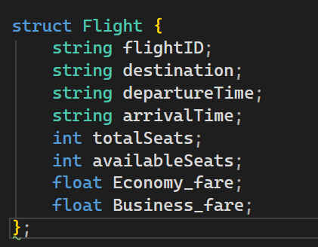

- Passenger Structure:

The Passenger structure stores all information related to a passenger including personal details and booking information.

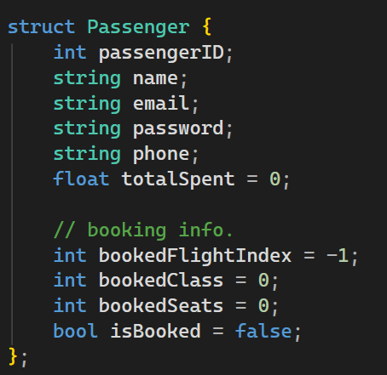

- Admin Structure:

The Admin structure stores login credentials of the system administrator. It allows secure access to administrative functions.

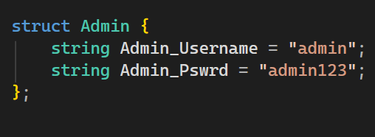

6. Functions:
The functions used in this Airline Management System are responsible for handling admin authentication, flight management, passenger registration, and booking operations. These functions allow the admin to add, update, view, and remove flights and passengers, while passengers can book flights, cancel reservations, and generate booking reports. Together, these functions ensure smooth and efficient operation of the entire system.
- Void Save Admin
- Void Admin login
- Void load Admin
- Void load Flights
- Void add Flights
- Void remove Flights
- Void View Flights
- Void Update Flights
- Void load Passenger
- Void Add Passenger
- Void View Passenger
- Void Update Passenger
- Void remove Passenger
- Void Book Flights
- Void Cancel Reservation
- Void Generate Report

- Admin login:
This function authenticates the admin by checking the entered username and password. It allows access to the admin menu after successful login.

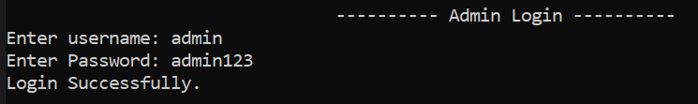

- Add Flights:

This function allows the admin to add new flights to the system.
The flight details are saved permanently in the file.

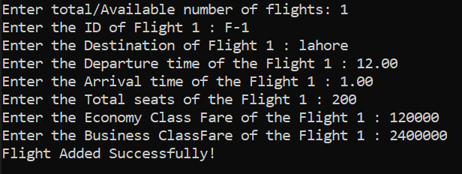

- Remove Flights:

This function removes a selected flight from the system.
It updates the flight file after deletion.

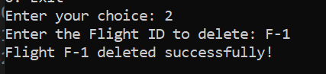

- View Flights:

This function displays all available flights with complete details.
It helps passengers and admin view flight information.

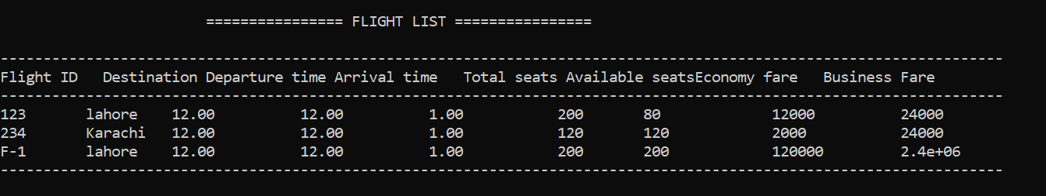

- Update Flights:

This function updates flight records after booking or cancellation.
It maintains accurate seat availability in the system.

- Add Passenger:
This function registers a new passenger in the system.
It generates a unique passenger ID and password.

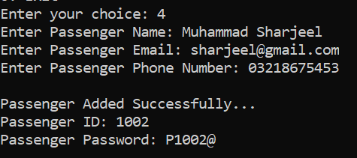

- View Passenger:
This function displays all registered passengers and their booking status. It is mainly used by the admin.

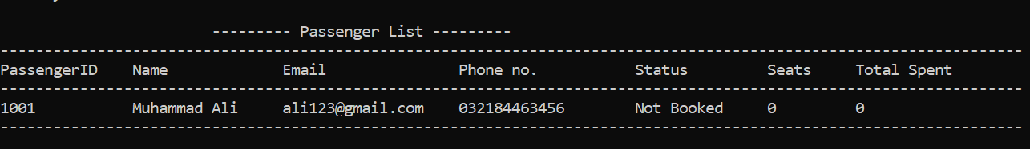

- Update Passenger:
This function allows updating passenger information such as name, email, or phone number. The updated data is saved back to the file.

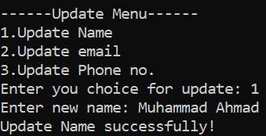

- Book Flights:
This function allows passengers to book flights by destination, class, and seats. It calculates fare and updates booking records.

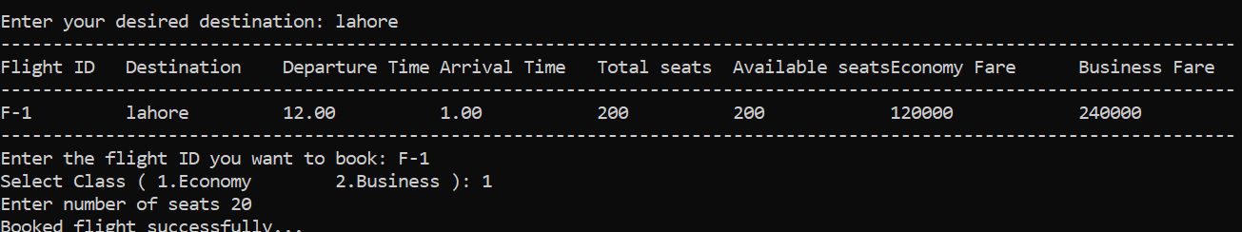

- Cancel Reservation:
This function cancels an existing flight booking. It restores seat availability and processes refund information.

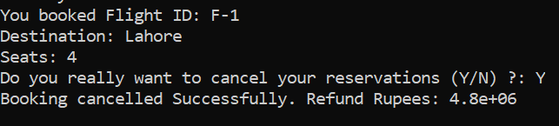

- Generate Report:
This function generates a detailed booking report for the passenger. It displays passenger details, flight information,
, total fare.

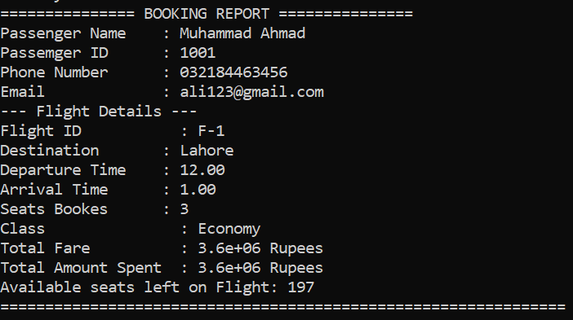
Conclusion:
The Airline Management System successfully fulfills the objectives of managing flights, passengers, and reservations in an organized and efficient manner. The system provides secure access for both admin and passengers, allowing accurate handling of flight schedules, seat availability, and fare calculations. By using structured programming concepts such as functions, structures, and file handling, the project demonstrates effective data management and practical implementation of real-world airline operations.

==========================

